**1.1 BACKGROUND**

We all know that artificial intelligence is the need of hour. Artificial Intelligence is a way of making a computer, a computer-controlled robot, or a software think intelligently, in the similar manner the intelligent humans think. We have gone through many text guidelines related to artificial intelligence which aims at creating similar intelligence in machines that we find and regard high in humans.We also gone through text guidelines related to python, various python modules which aims at providing programmers to express concepts in fewer lines of code, work quickly and integrate systems more efficiently.

This project “TechnoMate” which is based on speech recognition system, aims at providing assistance operating system that takes user voice as input , recognizes it and accordingly performs various tasks. Long term goal is to create an OS which could adapt itself according to the user's needs. Like if a doctor is using the OS, it will adapt itself so as it is capable of helping him out in his field like searching for new techniques, medicines, help in their research, etc

**1.2 AIM AND OBJECTIVES**

“TechnoMate ” is basically an speech recognition types of application based on Artificial Intelligence(AI).

**Objectives:**

* To automize all the task of a computer.
* Launch windows on any drive on computer.
* Open any files from file system
* Reboot or shut down PC
* Control Panel settings
* To fetch the most useful information rather than extracting whole data.(Efficient search from web)
* Searching from Google(Web Search).
* To make easy to user to control the system.
* Mouse Automation
* Play Music
* To help the blind people control the system.
* To develop an AI(Artificial Intelligence) based application that works on human voice.
* Social Media Handling
* Open facebook , twitter, etc
* Login or logout.

**1.3 REQUIREMENT ANALYSIS**

**HARDWARE REQUIREMENTS:**

CPU-1.6 GHZ

RAM-4 GB

DISPLAY- better VGA card

Hard Disk Space-16 MB

**SOFTWARE REQUIREMENT:**

* Operating system –All Windows version
* Front End-Python
* Technology Used-Artificial Intelligence(AI)

**CHAPTER 01 – LITERATURE SURVEY**

* 1. **LITERATURE SURVEY**

1. **Artificial Intelligence(AI)**

According to the father of Artificial Intelligence, John McCarthy, it is *“The science and engineering of making intelligent machines, especially intelligent computer programs”.*

Artificial Intelligence is a way of making a computer, a computer-controlled robot, or a software think intelligently, in the similar manner the intelligent humans think.AI is accomplished by studying how human brain thinks, and how humans learn, decide, and work while trying to solve a problem, and then using the outcomes of this study as a basis of developing intelligent software and systems.

**Goals of AI**

* To Create Expert Systems − The systems which exhibit intelligent behavior, learn, demonstrate, explain, and advice its users.
* To Implement Human Intelligence in Machines − Creating systems that understand, think, learn, and behave like humans.

## What Contributes to AI?

Artificial intelligence is a science and technology based on disciplines such as Computer Science, Biology, Psychology, Linguistics, Mathematics, and Engineering. A major thrust of AI is in the development of computer functions associated with human intelligence, such as reasoning, learning, and problem solving.

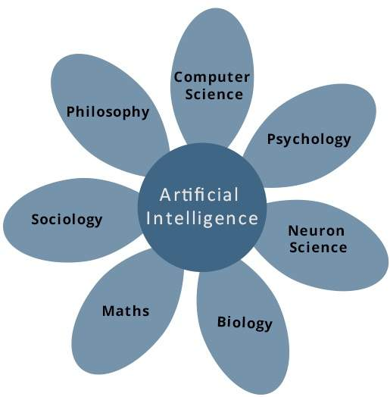

1. **Python**

## Introduction:

Python is a popular programming language. It was created in 1991 by Guido van Rossum. Python is an [interpreted](https://en.wikipedia.org/wiki/Interpreted_language), [high-level](https://en.wikipedia.org/wiki/High-level_programming_language), [general-purpose programming language](https://en.wikipedia.org/wiki/General-purpose_programming_language).It features a [dynamic type](https://en.wikipedia.org/wiki/Dynamic_type) system and automatic [memory management](https://en.wikipedia.org/wiki/Memory_management). It supports multiple [programming paradigms](https://en.wikipedia.org/wiki/Programming_paradigm), including [object-oriented](https://en.wikipedia.org/wiki/Object-oriented_programming), [imperative](https://en.wikipedia.org/wiki/Imperative_programming), [functional](https://en.wikipedia.org/wiki/Functional_programming) and [procedural](https://en.wikipedia.org/wiki/Procedural_programming). It also has a comprehensive [standard library](https://en.wikipedia.org/wiki/Standard_library)

It is used for:

* web development (server-side),
* software development,
* mathematics,
* system scripting.

### What can Python do?

* Python can be used on a server to create web applications.
* Python can be used alongside software to create workflows.
* Python can connect to database systems. It can also read and modify files.
* Python can be used to handle big data and perform complex mathematics.
* Python can be used for rapid prototyping, or for production-ready software development.

### Why Python?

* Python works on different platforms (Windows, Mac, Linux, Raspberry Pi, etc).
* Python has a simple syntax similar to the English language.
* Python has syntax that allows developers to write programs with fewer lines than some other programming languages.
* Python runs on an interpreter system, meaning that code can be executed as soon as it is written. This means that prototyping can be very quick.
* Python can be treated in a procedural way, an object-orientated way or a functional way.

# Python Modules

A module is a file containing Python definitions and statements. A module can define functions, classes and variables. A module can also include runnable code. Grouping related code into a module makes the code easier to understand and use.

1. **Machine Learning**

**Arthur Samuel**, a pioneer in the field of artificial intelligence and computer gaming, coined the term **“Machine Learning”**. He defined machine learning as – **“Field of study that gives computers the capability to learn without being explicitly programmed”**.  
In a very layman manner, Machine Learning(ML) can be explained as automating and improving the learning process of computers based on their experiences without being actually programmed i.e. without any human assistance. The process starts with feeding a good quality data and then training our machines(computers) by building machine learning models using the data and different algorithms. The choice of algorithms depends on what type of data do we have and what kind of task we are trying to automate.

Machine learning is one of the most exciting technologies that one would have ever come across. As it is evident from the name, it gives the computer that which makes it more similar to humans: The ability to learn. Machine learning is actively being used today, perhaps in many more places than one would expect. We probably use a learning algorithm dozens of time without even knowing it. Applications of Machine Learning include:

* Web Search Engine: One of the reasons why search engines like google, bing etc work so well is because the system has learnt how to rank pages through a complex learning algorithm.
* Photo tagging Applications: Be it facebook or any other photo tagging application, the ability to tag friends makes it even more happening. It is all possible because of a face recognition algorithm that runs behind the application.
* Spam Detector: Our mail agent like Gmail or Hotmail does a lot of hard work for us in classifying the mails and moving the spam mails to spam folder. This is again achieved by a spam classifier running in the back end of mail application.

**CHAPTER 02 – DESIGN METHODOLOGY**

* 1. **BLOCK DIAGRAM**

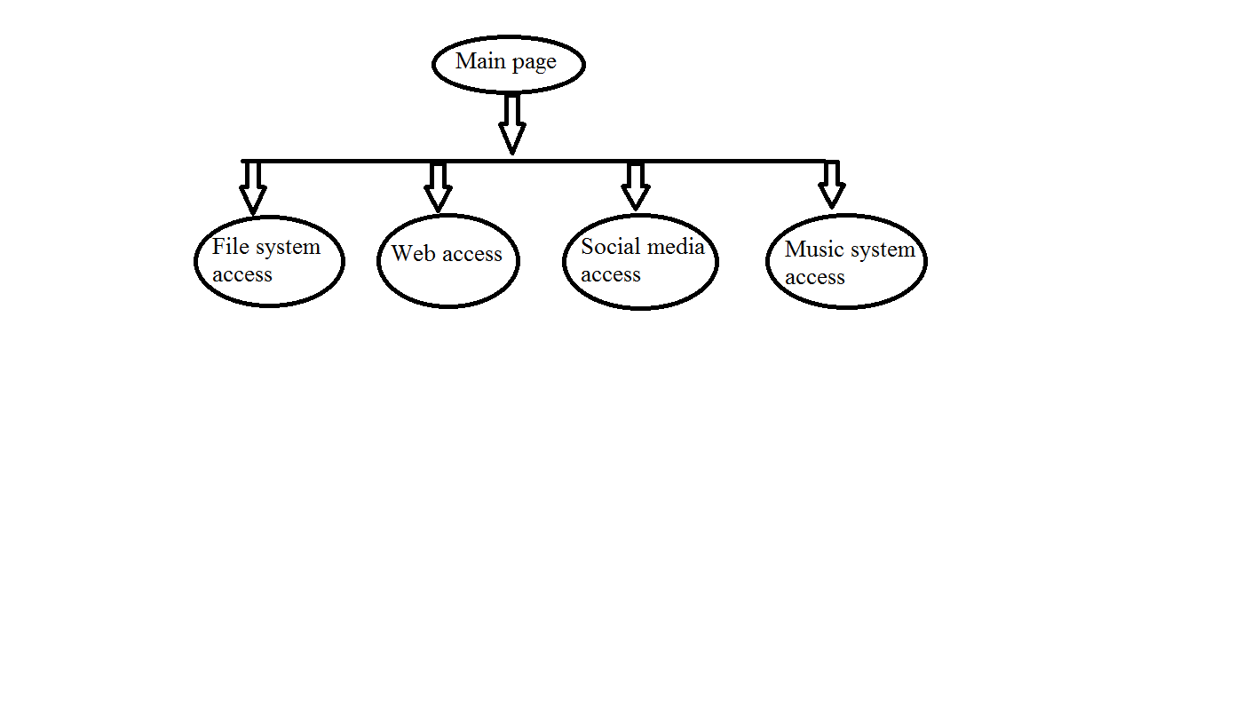

**Fig. I:Main Structure**

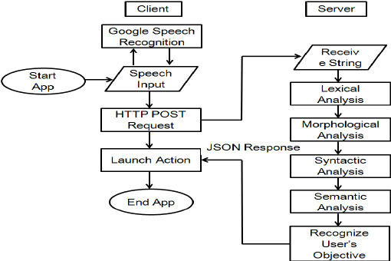

**Fig.II :ER Diagram**

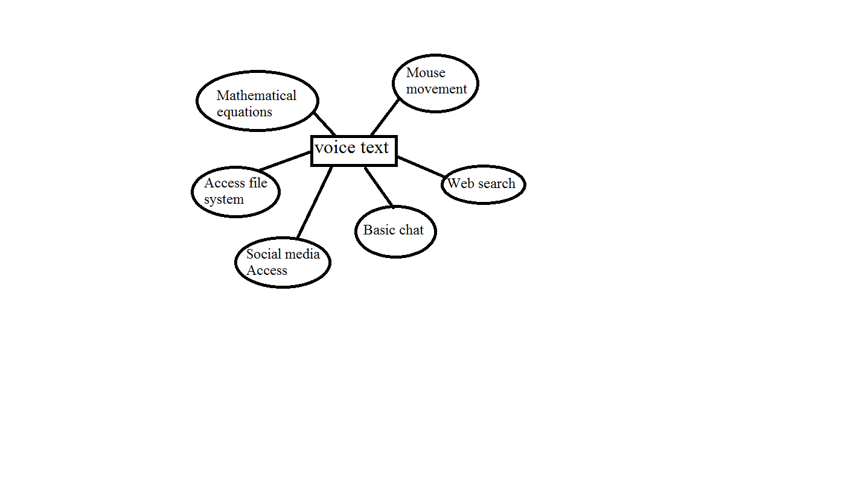

**Fig.III : Main Layout**

**CHAPTER 03 - IMPLEMENTATION**

**3.1 MODULE 01:SYSTEM HANDLING**

We are providing interactive system handling functions.This includes following functions:

* Control Windows

In this we can launch windows, shut down our PC, minimize window, maximize window, etc.

* Accessing file system

We can open any file from file system

* Accessing music system

We can play music from music system

* Control Panel Settings

We can directly go to control panel systems

For providing this facilities we have used following python modules:

* Speech_recognition:

Google has a great Speech Recognition API. This API converts spoken text (microphone) into written text (Python strings), briefly Speech to Text. You can simply speak in a microphone and Google API will translate this into written text. The API has excellent results for English language.

* PyAudio:

PyAudio provides [Python](http://www.python.org/) bindings for [PortAudio](http://www.portaudio.com/), the cross-platform audio I/O library. With PyAudio, you can easily use Python to play and record audio on a variety of platforms, such as GNU/Linux, Microsoft Windows, and Apple Mac OS X / macOS.

* os module:

The OS module in python provides functions for interacting with the operating system.OS, comes under Python’s standard utility modules. This module provides a portable way of using operating system dependent functionality. The *os* and *os.path* modules include many functions to interact with the file system.

* ctypes:

[ctypes](https://docs.python.org/3/library/ctypes.html#module-ctypes)is a foreign function library for Python. It provides C compatible data types, and allows calling functions in DLLs or shared libraries. It can be used to wrap these libraries in pure Python

* boto3

boto3 is the Amazon Web Services (AWS) SDK for Python. It enables Python developers to create, configure, and manage AWS services, such as EC2 and S3. Boto provides an easy to use, object-oriented API, as well as low-level access to AWS services

* playsound

The playsound module is a cross platform module that can play audio files. This doesn’t have any dependencies, simply install with pip in your virtualenv and run!

* 1. **MODULE 02: WEB SEARCHING**

We are providing the intelligent web searching from Google .It fetches useful information rather than whole data. By giving some querry it extracts data from google and displays it in the form of text as well speaks the text.

For providing this facilities we have used following python modules:

* Google:

Use the simple, clean library to make calls from [Python](https://www.python.org/) to one of the many [supported Google APIs](https://developers.google.com/api-client-library/python/apis/).We can open the page in google , perform searching . To open a page in the browser, use the open() function.

**3.3 MODULE 03: SOCIAL MEDIA ACCESS**

We are providing social media access through this software .It includes

* Opening social media sites likes facebook, twitter,etc
* Automatically log in and log out from facebook,twitter,instagram,etc

For implementing this we have used following module:

* webbrowser:

The [webbrowser](https://pymotw.com/2/webbrowser/#module-webbrowser) module includes functions to open URLs in interactive browser applications. The module includes a registry of available browsers, in case multiple options are available on the system. It can also be controlled with the BROWSER environment variable.

For ex:

importwebbrowser

webbrowser.open('http://docs.python.org/lib/module-webbrowser.html')

The URL is opened in a browser window, and that window is raised to the top of the window stack.

**3.4 MODULE 04: MOUSE NAVIGATION**

This will be useful for automating tasks on your computer like programs you write that directly control the keyboard and mouse. These programs can control other applications by sending them virtual keystrokes and mouse clicks, justpython3- as if you were sitting at your computer and interacting with the applications yourself. This technique is known as graphical user interface automation, or GUI automation for short.

For implementing this we have used following modules:

* PyAutoGUI:

PyAutoGUI is a cross-platform GUI automation Python module for human beings. Used to programmatically control the mouse & keyboard. The pyautogui module has functions for simulating mouse movements, button clicks, and scrolling the mouse wheel.

**3.5 MODULE 05: MATHEMATUCAL CALCULATUION**

This will be used for mathematical calculations like integration, derivation ,etc. For this we have used following python module

* Wolframalpha

Wolfram Alpha is a computational search engine that tends to evaluate what the user asks.Imagine you are asking :”Integrate 1/x” the it will answer “log x + constant”.

**3.6 MODULE 06:BASIC CHAT**

ChatterBot is a Python library that makes it easy to generate automated responses to a user’s input. ChatterBot uses a selection of machine learning algorithms to produce different types of responses. This makes it easy for developers to create chat bots and automate conversations with users. For more details about the ideas and concepts behind ChatterBot see the [process flow diagram](https://chatterbot.readthedocs.io/en/stable/#process-flow-diagram).

An example of typical input would be something like this:

user: Good morning! How are you doing?

bot: I am doing very well, thank you for asking.

user: You're welcome.

bot: Do you like hats?

**3.7 MODULE 07: IMAGE PROCESSING**

This will extract text from the particular image. For this Tracert module is used

**CHAPTER 04 – RESULT AND ANALYSIS**

**4.1 RESULT AND ANALYSIS**

As a result of this project we have found that user using this software are able to control their system through their voice and perform variety of tasks. This system allows users to perform following task which includes:

* Web Searching
* Social Media Accessing
* Mouse Automation
* Control Panel Settings
* Playing Music
* Accessing File Systems
* Navigating Windows
* Mathematical Calculations
* Image Processing

Thus from this project we have analyse that user is able to perform tasks easily through our voice. It is assistance operating system that takes user voice as input , recognizes it and accordingly performs various tasks.

**4.2 SCREENSHOTS**

**HOME PAGE:**

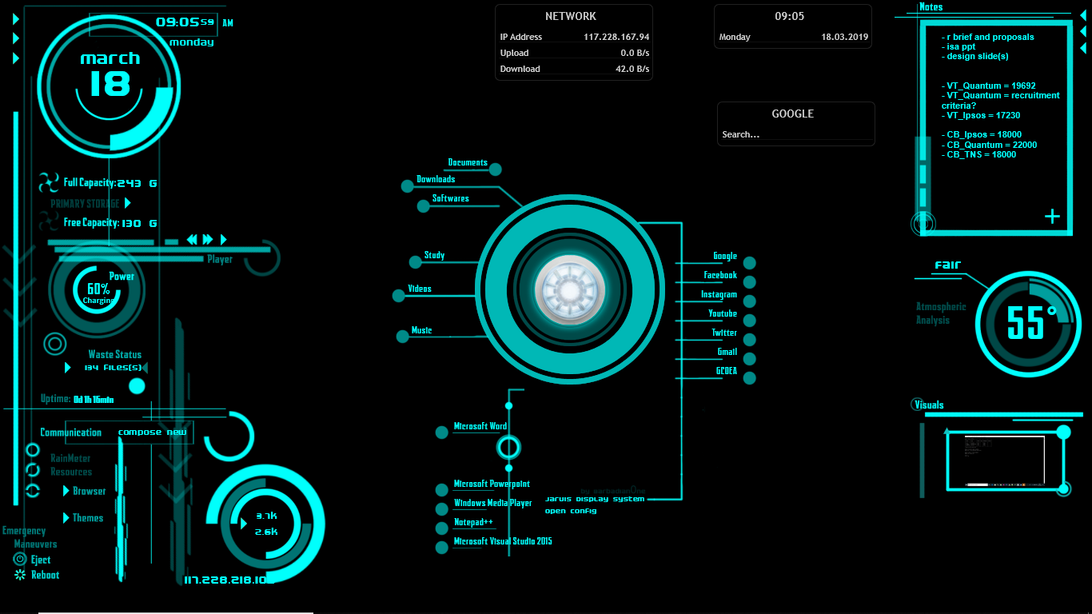

**WEB SEARCHING:**

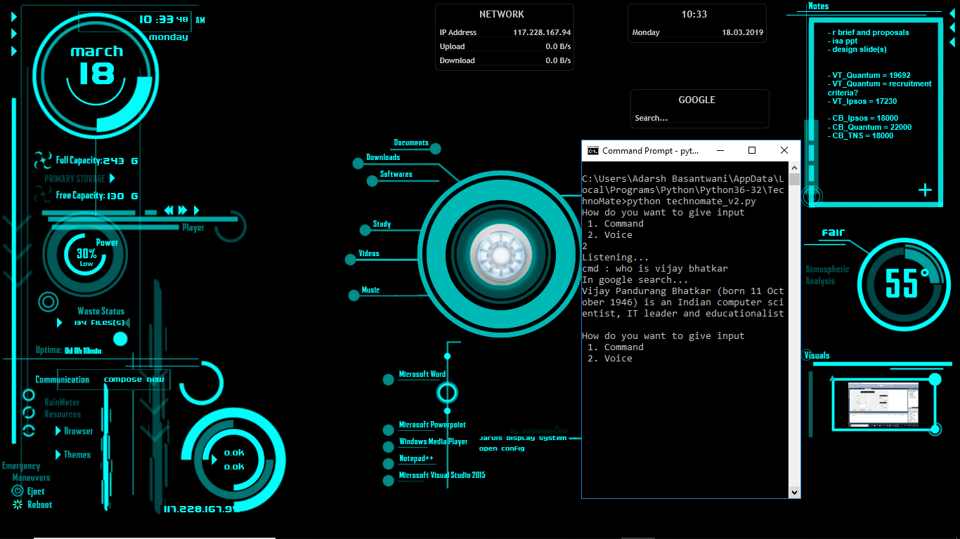

**IMAGE PROCESSING:**

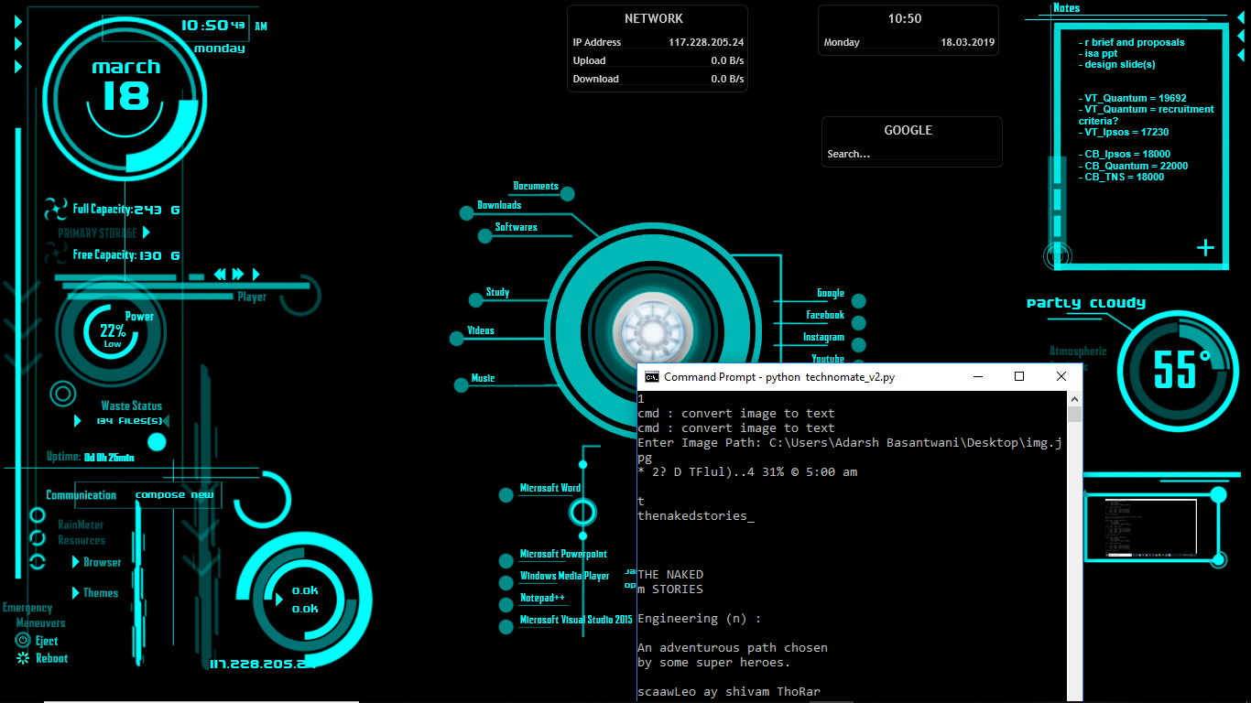

**CONTROL PANEL SETTINGS:**

* 1. **SYSTEM PROPERTIES:**

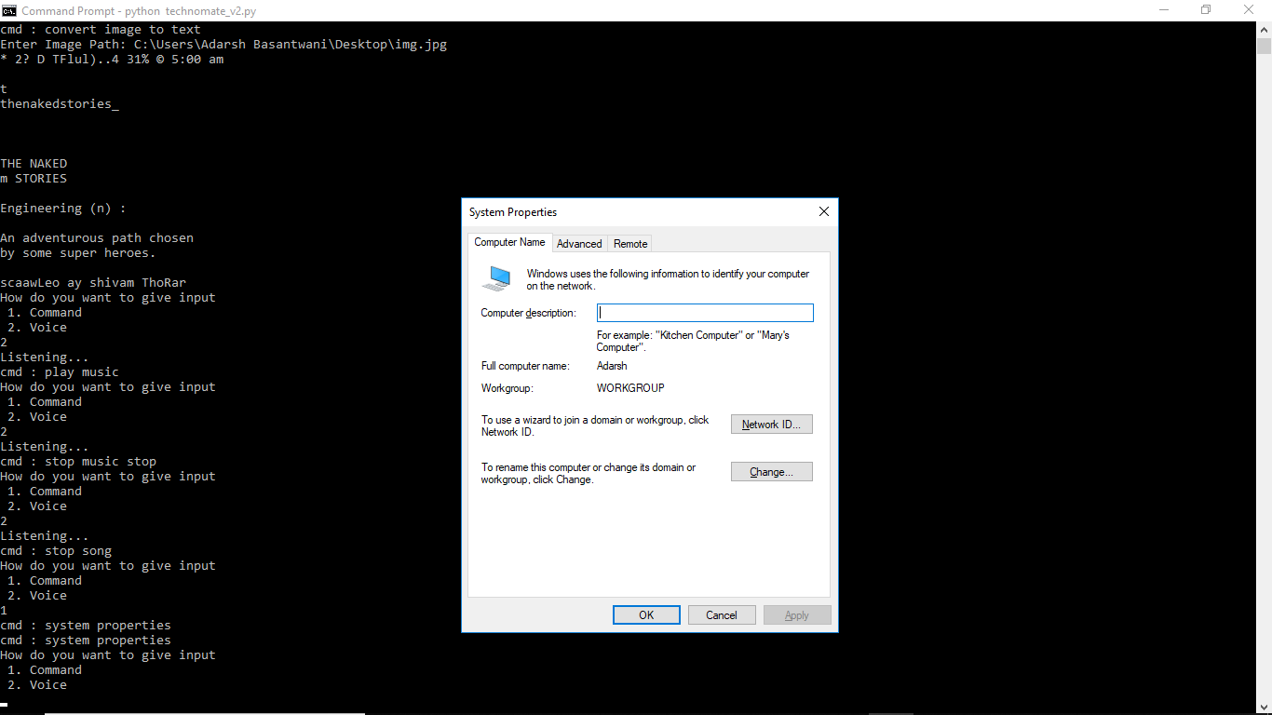

* 1. **ADD/REMOVE PROGRAMS:**

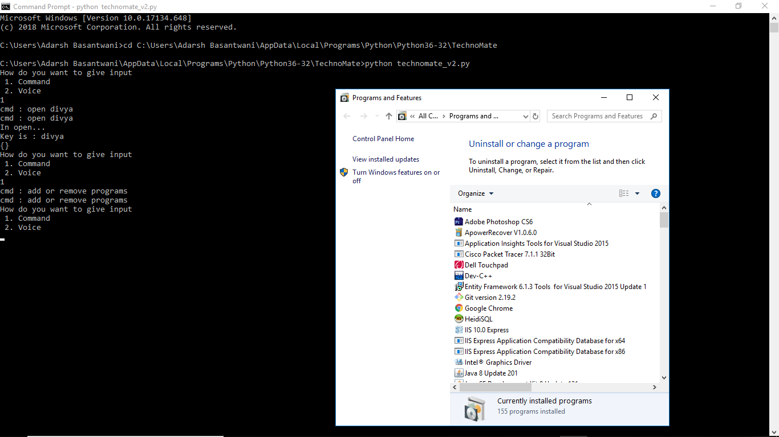

**CHAPTER 05 - TESTING**

**5.1 TESTING:**

SOFTWARE TESTING:

Software testing is an investigate conducted to provide stakeholders with information about the quality of the product or services under test. Software testing can also provide an objective.

MANUAL TESTING:

We checked all the functions and means of editor working properly or not.

SYSTEM TESTING

Entire system is tested as per requirements. We have tested all menus and submenus are working properly or not. Tested Black-box type testing that is based on overall requirements specifications, covers all combined parts of a system.

UNIT TESTING

Unit testing is a testing of individual software components or modules. Unit testing is typically done by the programmer and not by testers,as it require detailed kmowledge of the internal program design and code. In our project we tested individual function of menu, sub menu, spell checking, etc.

INTEGRATION TESTING

Testing of integrated modules to verify combined functionality after integration. Modules are typically code modules, individual applications, client server applications on a network, etc. This type of testing is especially to client/server and distributed system. We have checked whole project by combining all the modules.

**CHAPTER 06 - ADVANTAGES AND DISADVANTAGES**

**6.1 ADVANTAGES AND DISADVANTAGES**

Advantages

* This software is easy to use.
* Can work with variety of commands.
* Custom commands
* Secure
* Helpful for disabled
* Artificial intelligent

Disadvantages

* Require strong internet connection.
* It cannot work in noisy environment.

**CHAPTER 07 - APPLICATIONS AND FUTURE SCOPE**

**7.1 APPLICATIONS AND FUTURE SCOPE**

Probably the most important and useful application field in speech synthesis is the reading and communication aids for the blind. Before synthesized speech, specific audio books were used where the content of the book was read into audio tape. It is clear that making such spoken copy of any large book takes several months and is very expensive

Now this software is used for PC automation. But in future, this software is used for building automation, lab automation, machine automation, car automation, etc

Also we can achieve the concept of IOT(Internet of things).

At some point in the future, speech recognition may become speech understanding. The statistical models that allow computers to decide what a person just said may someday allow them to grasp the meaning behind the words. Although it is a huge leap in terms of computational power and software sophistication, some researchers argue that speech recognition development offers the most direct line from the computers of today to true artificial intelligence. We can talk to our computers today. In 25 years, they may very well talk back.

**CHAPTER 08 - CONCLUSION**

**CONCLUSION**

Speech recognition system has been developed steadily over the last decades and it has been incorporated into several new applications. For most applications, the intelligibility and comprehensibility of recognition speech have reached the acceptable level. However, in prosodic, text preprocessing, and pronunciation fields there is still much work and improvements to be done to achieve more natural sounding speech.

If speech recognition systems someday achieve a generally acceptable level, we may develop for example a communication system where the system may first analyze the speakers' voice and its characteristics, transmit only the character string with some control symbols, and finally synthesize the speech with individual sounding voice at the other end. Even interpretation from a language to another may became feasible. However, it is obvious that we must wait for several years, maybe decades, until such systems are possible and commonly available.

**APPENDIX I: BIBLIOGRAPHY**

**BIBLIOGRAPHY:**

Website references:

* <https://electronics.howstuffworks.com/gadgets/high-tech-gadgets/speech-recognition.htm>
* <https://www.w3schools.com/python/>
* <https://www.geeksforgeeks.org/python-modules/>
* <https://www.tutorialspoint.com/artificial_intelligence_with_python/index.htm>
* www.google.com
* https://www.youtube.com/watch?v=Wx7RCJvoCMc